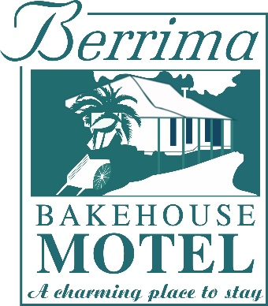

CONDITIONS OF STAY

Thank you for choosing to stay with us and we hope that you enjoy your stay.

By making a booking to stay at our Motel, you agree to be bound by the conditions as below:

Room Check-in/Check-out

We uphold a strict adherence to our check-in time of 2:00 pm. Requests for early room access cannot be accommodated.
On the day of your departure, please vacate your room by 10:00 am. Requests for late check-out cannot be accommodated.

Parking

Onsite parking is reserved for in house guests only. One motor vehicle per room. Please park your vehicle in your allocated parking bay. Additional cars to be parked in neighbouring streets. Trucks, trailers, campervans and motorhomes are not permitted.

Guest Kitchenette

We do not provide meals however, Complimentary fresh milk and cereal packets are available.
Please check package labelling to ensure you consider any personal food intolerances.

Special Requests

Please advise the Motel in advance should you require a Portacot, rollaway bed (children aged up to 12 years), or shower chair.

Pet Policy

Pets are not permitted on Motel Property or guest rooms. Exemption for service animals with valid government issued certification and the guest must provide for bedding and pet needs.

No Smoking Policy

All rooms are designated non-smoking. Smoking of cigarettes or tobacco products is not permitted in guest rooms or outside guest room doorways. Evidence of smoking in guest rooms will be subject to our fees and charges.

Swimming Pool

The pool and surrounding area is open during the Summer months although may on occasion be closed for routine maintenance.

Guests enter the pool and surrounding area at their own risk. The Motel will not be responsible for any injury to guests or their visitors while using Motel facilities.

Children must be accompanied by a parent, guardian, or responsible adult and under strict supervision.

Guests must not enter the pool whilst under the influence of alcohol, medication, or illicit substances.

Food and Beverage and glassware is not permitted in the pool area.

Diving into the pool is strictly prohibited.

Caution must be exercised.

BBQ

Guests undertake to reasonably clean the BBQ and equipment after use and to dispose of all rubbish in the bins.

Caution is to be exercised in the operation of the BBQ.

Fees and Charges

Entry to BBM rooms is conditional upon supply of a valid credit card and valid government issued identification.
If in the course of a guests stay, and attributable to any guests or visitors of that room, should any unforeseen expenses become apparent, the guests credit card will be charged an amount, appropriate to the expense, at a rate determined by the management of the Motel. In addition, until the affected room is fit for future guests, the appropriate nightly rate will be charged to the guest’s credit card.

Fees chargeable to a guest account include, and are not limited to:
- Smoking, smoke odour, room degradation (such as vomit, red wine spills, general damage, and any issue sufficient to result in a room being withdrawn from future sale).
- Stains to bedding and towels resulting from body tanning products.

Cancellation

Reservations cancelled outside of 48 hours of intended arrival date will not incur a cancellation fee.
Reservations cancelled at/within 48 hours of intended arrival date will result in forfeiture of the applicable one night stay.

Enforcement of Terms & Conditions

Copies of the Terms and Conditions are available at Motel Reception, in each motel room, and website. By making a reservation at the Motel, you agree to be subject to these terms and conditions.

Correction and Changes

The information on the property website may contain errors or inaccuracies and may not be complete or current. We therefore reserve the right to correct any errors, inaccuracies, or omissions and to change or update information at any time without prior notice. Please note that such errors, inaccuracies, omissions, or changes may relate to product description, pricing, and availability.
We apologise for any inconvenience this may cause you.

Our Responsibility

The Motel is not responsible for, or liable for any damage, theft, or loss of any items, property, or valuables on or at the Motel premises.

The Motel is not responsible for, or liable for, any loss or damage to any personal property, injury, or fatality arising from whatsoever reasons whilst occupying a room or on Motel premises.

Berrima Bakehouse Motel Team

